CONFERENCE NOTICE:
Genomics in Medicine
Emerging Technologies and Bioinformatic Challenge

When: December 5th and 6th, 2019
Where: Room CHEB 170, Collaborative Health Education Building, Faculty of Medicine, Dalhousie University
Keynote Speakers:
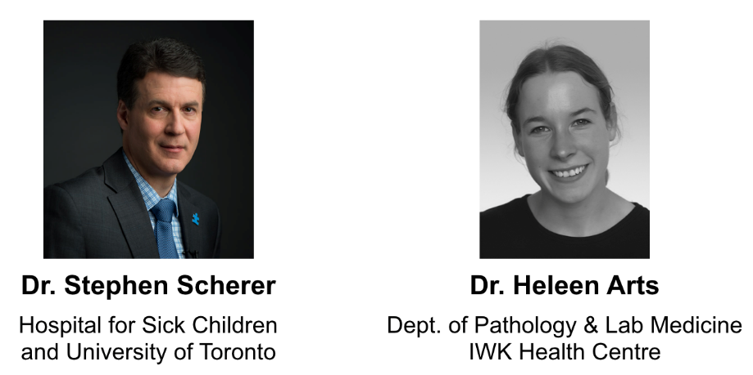
Events include:
• Presentations from Dalhousie researchers and their trainees
• Poster sessions
• Vendor displays and presentations from Illumina, 10X Genomics, and PacBio
• Tours of CORES facilities
• Prizes for best trainee talks and posters

REGISTER HERE
Are you presenting a poster? If so, please also register here
PROGRAM:
THURSDAY DECEMBER 5TH
9:15 AM Opening Remarks
SESSION 1 — BIOINFORMATICS TO BEDSIDE I (9:25 – 10:40 AM) Chair: Andrew Orr
9:25 - 9:50 Karen Bedard Clinical genomics and diagnostics
9:50 - 10:15 Sarah Dyack Medical genetics at the IWK: who we are and what we do
10:15 - 10:40 Paola Marignani Cancer transcriptomics
10:40-11:15 AM Coffee Break + Posters + Vendor Displays
KEYNOTE 1 — 11:15 AM – 12:15 PM
STEPHEN SCHERER Hospital for Sick Children and
University of Toronto
Genomes to genes to outcomes in autism
12:15-1:15 PM Lunch + Posters + Vendor Displays
SESSION 2 — TECH PLATFORMS: OPTIONS AND OPPORTUNITIES (1:15 – 4:00 PM) Chair: Jon Jerlström Hultqvist
1:15 - 1:35 Mena Farag Illumina
1:35 - 1:55 Adriana Suarez 10X Genomics
1:55 - 2:15 Sal Mazza PacBio
2:15-2:25 PM Break
2:25 - 2:45 Mat Nightingale CORES—Genomics Facility
2:45 - 3:05 Alejandro Cohen CORES—Biological Mass Spectrometry Facility (BMS)
3:05 - 3:15 David Malloy CORES—Zebrafish Facility
3:15 - 3:25 Derick Rowter CORES—Flow cytometry
3:25 - 3:30 Stephen Whitefield CORES—Cellular & Molecular Digital Imagine Facility (CMDI)
3:30 - 3:35 Mary Ann Trevors CORES—Electron microscopy
3:35 - 3:40 Andrew Reid CORES—Brain Bank
3:40 - 4:00 Morgan Langille Integrated Microbiome Resource
4:00 - 5:00 PM CORES Tours
4:00 PM - Social events
FRIDAY DECEMBER 6TH
KEYNOTE 2 — 9:15 – 10:15 AM
HELEEN ARTS Department of Pathology & Lab Medicine, IWK Health Centre
Ciliopathies
10:15 - 10:45 AM Coffee Break + Posters + Vendor Displays
SESSION 3 — NEW TECH, NEW APPLICATIONS (10:45 – 12:00 PM) Chair: Wenda Greer
10:45 - 11:10 Andrew Orr and Mat
Nightingale
Structural variation in Mendelian disorders using the Bionano
platform
11:10 - 10:35 Landon Getz TN-Seq for probing bacterial pathogenesis
10:35 - 12:00 Dudley Chung Genome editing with CRISPR-Cas9
12:00 - 1:00 PM Lunch + Posters + Vendor Displays
SPECIAL PRESENTATION — 1:00 – 1:20 PM
STEVE ARMSTRONG Genome Atlantic Genome Atlantic—mission and funding opportunities
SESSION 4 — BIOINFORMATICS TO BEDSIDE II (1:20 – 2:35 PM) Chair: Leah Cahill
1:20 - 1:45 Manal Elnenaei Ultra low depth-WGS outperforms FISH in scope and
resolution for detection of copy number abnormalities in
multiple myeloma
1:45 - 2:10 Johane Robitaille Genomics of inherited developmental retinal vascular diseaase
and a tour of CGEM
2:10 - 2:35 Rudolf Uher Polygenic scores in the prediction and prevention of mental
illness
2:35-2:45 PM Break
SESSION 5 — MICROBIOMICS (2:45– 4:00 PM) Chair: Morgan Langille
2:45 - 3:10 Andrew Roger Genomics and metagenomics of Blastocystis in the human gut
3:10 - 3:35 Katherine Dunn Metagenomics: perspectives from pediatric Crohn’s disease
3:35 - 4:00 Patrick Slaine Genomics of influenza virus
4:00 - 4:10 PM Poster awards + closing remarks

