POLI 4390: PRACTICUM PLACEMENT
IN PUBLIC POLICY: NGOS AND GOVERNMENT SERVICES
Instructor: Dr. Denike
Written Report
Lucy Fox
Student ID: B00847646



For my internship this semester, I have been placed at the Halifax Sexual Health Centre (HSHC). To provide a comprehensive definition of what HSHC does and strives to be, I will share the organization's vision, mission, and values. HSHC's vision is for "all members of our community to have full, equal, non-judgmental, and safe access to sexual and reproductive health care and education" (HSHC, 2023). The mission of the Halifax Sexual Health Centre "is to improve and optimize the sexual health of all members of our community by providing high-quality and caring services and empowering clients to make healthy choices" (HSHC, 2023). The organization's values include being inclusive and respectful of diversity, respectful of client confidentiality, pro-choice, sex positive, focused on the needs of our clients and community, youth positive, and 2SLGBTQIA+ community positive. I was very excited about being placed at this organization, as the values of HSHC align completely with the qualities I hope to bring to any place of employment, and any space in my personal life. My major at Dalhousie is Gender and Women’s Studies; my minor is International Development; and I have completed a certificate in Indigenous Studies. This placement touches on elements of each of my areas of study, which I was pleasantly surprised by. Some skills and values learned in my degree are learning to identify, articulate, and analyze subtle, as well as overt, cultural practices that promote and even institutionalize specific notions around gender, race, culture, sexual orientation, etc. Within this internship placement, I have been able to implement and celebrate these values that I have learned throughout my degree. Some additional noteworthy aspects of this clinic are that it is free, with a valid healthcare card, and for those who don’t have a healthcare service, it can still be accessed by paying out of pocket. The clinic is youth-friendly and doesn’t require parental consent to access services. This is a value that is very important to me, as many youth do not get the sexual healthcare they need out of fear of punishment and judgment of family members. But within this clinic, all patients’ medical information is confidential, regardless of age. The office is wheelchair accessible and free, creating an accessible space. Some of the services the clinic offers are; Pap tests, STI tests, IUD insertion and removal, STBBI testing, and gender-affirming care. The offering of gender-affirming care at this clinic was very important to me as the lack of access to gender-affirming care in Nova Scotia is very disappointing, so I was very excited to be at a clinic that offers comprehensive care to all community members. Below, I have attached links to the HSHC website, if there is curiosity about any services they offer or values they hold:

Sexual Health
- Useful Terms to Understand
- Sexually Transmitted Infections
- Birth Control
- Barriers
- Pregnancy
- Fun Sex
- Sex Without Consent
- Other Sexual Health Concerns

Resources
- Community Directory
- Order Supplies
- Workshops, Fairs, Consultations, and Presentations
- Transgender Abortion Access Manual
- Partner Tested Positive for… Guide
- PrideHealth Gender Affirming Care Navigation
- Action Canada Resource Hub

Get involved
- Volunteer
- Fundraising
- Job Opportunities
- Internships & Placements
- Physician Recruitment

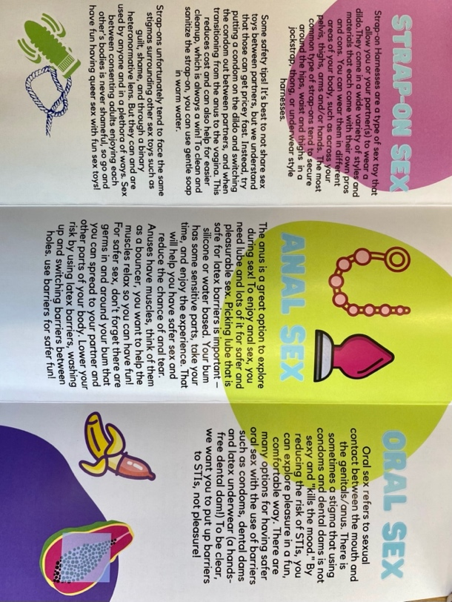
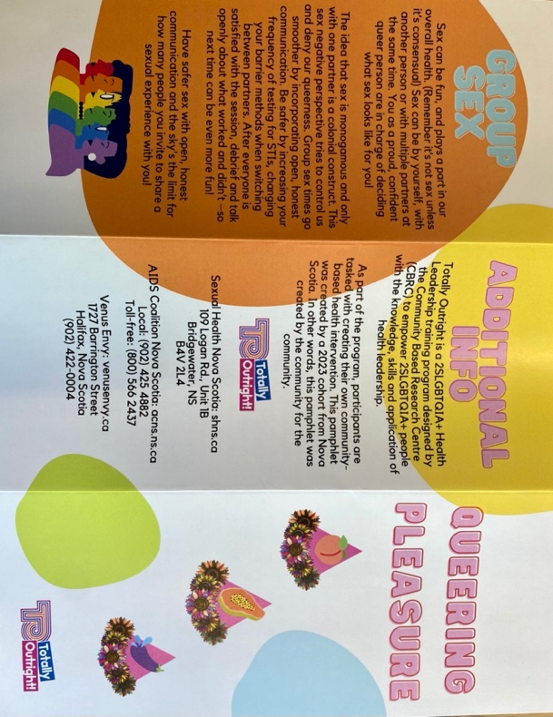
Now that I have explained HSHC, I would like to discuss what I did during my internship. At the beginning of my internship, my supervisor messaged me and told me there was an opportunity to be part of a program called "Totally Outright". She suggested that for the first segment of my internship, I participate in this program and have it count towards my hours. This was a welcome surprise, as the "Totally Outright" program is a 2SLGBTQIA+ health leadership training program designed to empower 2SLGBTQIA+ people with the knowledge, skills, and application of health leadership. The purpose is to build community, learn about sexual and reproductive health topics, and gain paraprofessional experience. As a lesbian, I was so excited about this opportunity, as this is a course I would have taken in my free time. After completing many weeks of training, we participated in creating your own community-based health promotion! This meant that we selected a sexual and/or reproductive health issue that we found important and want to address in our community and create a knowledge product that will be shared with the public. This was exciting for me and the entire group. It’s not very often that a group of queer people gets to create a sexual health resource for other queer people, so we were all passionate about the project. All members of the group, myself included, have experienced a healthcare experience that made us feel othered and abnormal due to our sexuality and/or gender identity. As we found this to be a reoccurring theme throughout the training, we decided to make our community resource focused on normalizing queer sex and queer bodies. We shared this through a pamphlet and an online resource. We named our resource "Queering Pleasure" as we felt that many sexual health resources tend to focus on the risks and scary aspects of sex, especially when discussed in a queer context. We wanted to center pleasure in our resource and create a message that queer sex is pleasurable and exciting rather than the common narrative, which makes it sound scary and centers the risks. Of course, we discussed the risks associated with sex in the resource, but we framed these messages in a sex-positive way. The pamphlet is broken into four sections discussing strap-on sex, anal sex, oral sex, and group sex. Even when researching these topics, we found the desperate need for comprehensive queer sex education resources, as many of the resources we found were very cis and heteronormative. We hope that by creating this resource, we can welcome more people into a conversation about queer sex in a sex positive way and allow people to feel empowered in their bodies and sexual experiences. Below, I have attached photos of the pamphlet:

Throughout my time in the totally outright program, not only did I get to help create a sexual health resource and receive free training, but I also got to connect with other members of the queer community. Having two days a week surrounded by people who had and have similar experiences to me was very refreshing and exciting as well as educational.

Throughout this time, my supervisor at HSHC was very hands-off, and we didn’t have much communication. Once the program was over and I had distributed the pamphlets and we had wrapped up, I reached out to my supervisor to ask when I could start working at the clinic. This is an aspect of this placement that I think would be useful for others to know before taking it on: that it takes a lot of initiative, and you really have to keep in contact and ask for your shifts. This was not a problem for me, and I actually view it as very realistic and valuable experience before entering the work force in my field, but I thought I would mention this so future students being placed with HSHC have an understanding of the nature of the placement.

After the "Totally Outright" program ended, I began my work as a HSHC. On my first day I was trained, and I shadowed another employee to gain a better understanding of my role at HSHC. My tasks at HSHC include checking people in at the front desk. I verify their identity by checking their health card with the information we have in our system, and I check them in for their visit. If anyone is having an IUD inserted, a mandatory pregnancy test must be done. If I am greeting a client who is getting an IUD inserted, I welcome them into the clinic and explain to them how to provide a vaginal swab and urine sample. After they complete these tests, I collect them from the client and bring the vaginal swab to a location where it will be picked up and tested in a lab. And for the urine sample, I take it into a testing room and do a pregnancy test. After the pregnancy test, I mark the results on the client's file, and if it was negative, the IUD insertion goes ahead. Other responsibilities of mine at the clinic include cleaning the doctors’ rooms after each client. This includes changing the paper on the bed and the patient’s gown. I also spray the room, bed, and light with a disinfectant spray and dry it off. I ensure that all the tools the doctor needs for their next appointment are ready. Another aspect of my role is cleaning the medical instruments that the doctors use. The first step of this is scrubbing the instruments by hand (with gloves on, of course). Next, we soak them in a disinfectant solution for one hour, and then they are placed in a disinfectant machine. After this, the tools are put back in their place where all doctors can easily find them.

An aspect of this role that I find particularly rewarding is being the first point of contact at a clinic. I especially find this rewarding when speaking with queer and gender diverse clients. Clients have expressed comfort in speaking with someone who is part of the queer community when coming for appointments, as navigating healthcare systems as a queer individual can be very daunting. I myself resonate with this feeling, and I am beyond happy to be a figure of support for some clients. In the same way that clients find support in me, I find support in them. Being surrounded by many queer and gender diverse clients has also made me more comfortable with my own identity and community. Something that made me disappointed working in this internship is how far we have to go in relation to healthcare for our trans community. In Nova Scotia, the general wait time for gender-affirming hormone replacement therapy is around 3–10 months, and with the patients I have seen, their wait is always between 8–10 months. Some limited surgeries are available in Nova Scotia for those who choose to medically transition. However, many are not, and for those surgeries, there is availability in Montreal. The location where the procedure is performed is determined on a case-by-case basis (Gov. of NS, 2022). It depends on the nature and extent of the surgery and the availability of staff with surgical expertise. This means that many trans Nova Scotians must travel outside of the province to have their healthcare needs met. I am relieved these services are offered elsewhere. However, when people have to travel to gain access to medical care, a financial burden is posed, and they also leave their town and support network. Many people don’t have the financial means to travel, and even if they do, their figures of support may not be able to financially make the trip. Therefore, in a world already disadvantaging trans individuals, these challenges in accessing healthcare are discouraging and unfair. Trans individuals also have to go through a long process to become eligible for medical transition. Once you’ve been assessed for surgery, you and your physician, nurse practitioner, or specialist need to complete the Gender Affirming Surgery Application before you schedule or plan surgery. Your primary care provider will submit the application to MSI for pre-approval of coverage. In addition to the application, a psychosocial assessment letter and a post-operative care letter are required from your physician or nurse practitioner for out-of-province surgeries. This places another emotional burden on accessing care. There have been some criticisms about the need for a "letter of readiness" for those receiving their 3rd, 4th, or 5th, etc. gender-affirming surgery. This added step just adds more months (oftentimes years) onto the individual's care plan. Additionally, there is a long wait time just to see someone who can discuss the letter "readiness". This adds to the already painfully long wait times. This aspect of my placement has been -opening. I think it is very easy to lose sight of how the experience of this society differs so much depending on our identity. Working at this clinic made a passion I already had for access to gender-affirming care increase significantly. It has been found in countless studies and personal accounts that gender affirming care is linked to lowering rates of depression and suicide risk for trans youth (Enis, 2021). Learning more about the barriers trans Canadians face to accessing healthcare has been a main takeaway from this internship, which I expect will guide some of my career decisions in the future.

Overall, I learned so much at this internship. I loved my coworkers and feel very lucky to have been able to receive the training I have through the “Totally Outright” program and HSHC. I would recommend this placement for anyone who is looking to gain a deeper understanding of the health needs of our community and has an empathic and sensitive willingness to listen and learn.

Works Cited
Site sections. Government of Nova Scotia, Canada. (n.d.). Retrieved March 14, 2023, from https://novascotia.ca/dhw/gender-affirming-surgery/
Ennis, D. (2022, November 9). Gender-affirming care linked to less depression, lower suicide risk for Trans youth. Forbes. Retrieved March 14, 2023, from https://www.forbes.com/sites/dawnstaceyennis/2021/12/14/gender-affirming-care-linked-to-less-depression-lower-suicide-risk-for-trans-youth/
Mission & Values – Halifax Sexual Health Centre. (n.d.). Retrieved March 14, 2023, from https://hshc.ca/mission/

