Hayley Lowden

B00835401

POLI 4390

Friday, March 31, 2023

Written Report: Commonwealth Judicial Education Institute

For my placement, I was assigned to complete my 77 hours over the course of the semester with the Commonwealth Judicial Education Institution (CJEI). The CJEI is a linkage organization, made up of former judges, Chief Justices, legal scholars and legal actors, that connects all 54 countries whose judicial bodies follow the practice of the common law process. Through sharing legal and academic news, developing and running programs as well as hosting annual conferences, the CJEI works together to influence policy change and progress the common law justice system as a whole, at a global scale. Overall, CJEI strives to deliver judicial education and deliver judicial curricula in support of contemporary reform. For further clarification for future students taking this course, I have included at the bottom of this report the purposes of the institute that are outlined on their webpage (for more information please see www.cjei.org). This report will provide some insight with regards to what the CJEI does, what my role was during my time at the CJEI, some of the implications that I encountered and some suggestions regarding the type of student who may enjoy or benefit from a placement with the CJEI.

At the beginning of my placement, I spent the majority of my time becoming familiar with the CJEI and their goals as a non-governmental organization, dedicated to progressing the common law judicial system. I learned, that each year the CJEI chooses one or two legal/social justice issues in which they focus on for the entirety of the year. This year, during my time with them, these two topics regard Animal Rights and Human Trafficking. Additionally, with the help of my supervisors, Former Judge Sandra Oxner and Administrator Sandra Hutchings, we determined that my role with the CJEI over the semester would be to develop and edit the biennial newsletter that is shared with the entire CJEI organization at their biennial conference (coming up this July 2023). With that, I spent a decent amount of time during the beginning of my placement, reviewing their passed newsletters to become familiar with their style and formatting. Both of my supervisors throughout the first week were in contact with me and I was able to have a phone meeting with former Judge Sandra Oxner, as well as have an in-person meeting with Administrator Sandra Hutchings at the CJEI office to become familiar with the office and who I would be working with. Both Judge Oxner and Sandra Hutchings were excited and eager to help get me started and made me feel important as well as excited for the rest of the semester.

After becoming more familiar with the organization and the intentions of the newsletter that I would be working on, I was in a pretty good position with regards to knowing what I would be responsible for. I spent the next week or so developing a template for the newsletter and beginning to draft all emails that would need to be sent to the fellows of the CJEI in order to collect the relevant information that I would need to put the newsletter together. The goal of the newsletter is to update all bodies of the CJEI with relevant news, articles, cases and summaries of decisions, from each respective jurisdiction that would be of interest and importance to the other Commonwealth judiciaries. Specifically, we were looking for information consisting of judicial education programmes, new procedural rules, delay reduction strategies, use of technology in the justice system, improvements in court infrastructure, new initiatives regarding access to justice for the disadvantaged, landmark judgements etc. Furthermore, each newsletter consists of a legal article relevant to the CJEI. At first, I was under the impression that I would be writing the article that would be included in the newsletter and therefore spent some time brainstorming different angles with regards to the two highlighted topics and conducting research on the given topics. I was later informed that an article had already been written regarding an intensive study program that the CJEI had run a few months prior and collected/reviewed this article for inclusion. The CJEI is located on Dalhousie’s campus at the Weldon Law Building, however the office is only used by the Administrator (Sandra Hutchings) as the rest of the fellows who make up the CJEI work remotely from different parts of the world. Therefore, the office is particularly small and is not equipped for an ‘in-person’ co-op placement. With that, it was very convenient being located on Dalhousie’s campus as I was easily able to get there for occasional meetings. Additionally, at the end of the first few weeks, Judge Oxner and Sandra Hutchings were so kind as to take me to lunch to have an official meeting.

By the last week of January and the beginning of February, I had sent out the draft emails that I had been working and began to receive responses to my requests for submissions from each jurisdiction, for information and news to be included in the newsletter. To offer some insight with regards to the information included in the newsletter, submissions range from upcoming Judicial Education Master’s program from Universities in Singapore for example, to recent case law decisions and precedent from Hong Kong. Over the next week or two, I spent a considerable amount of time reviewing and analyzing the submissions received, with a lot of back and forth communication via email with my supervisors to determine the relevance of the submissions for inclusion in the newsletter. Additionally, I spent much of my time communicating back and forth with the fellows who had sent submissions to ensure that the relevant information was included, clarify what information we were looking for, clarify submission dates, answer general questions and make any other changes needed. These couple weeks spent communicating with different legal actors across the world and receiving educational judicial reform initiatives found in the submissions was most definitely my favourite part of my time with the CJEI. Considering that my communication was conducted through email, I did not get the opportunity to deeply engage with the fellows of the CJEI, but thoroughly enjoyed reading their submissions and gaining insight with regards to judicial reform initiatives around the world. Over the past 4 years of completing my undergraduate degree, I have developed quite the interest for working towards reforming local and global injustices, and it was really interesting to see first-hand this multilateral approach to reforming global injustices.

By the middle of February, I had received a number of submissions and determined with the help of my supervisors, which were to be included in the newsletter. Although I was still receiving submissions periodically, I had enough to begin putting together the newsletter. For any future student tasked with this project, I will note that you must be proactive and diligent about requesting these submissions, as it did take quite some time for different jurisdictions to compile their submissions and respond to my emails in a timely fashion. Additionally, I did have to send out one or two reminder emails in addition to the initial request to ensure that all relevant information had been received. Although this is unavoidable and can’t really be mediated by your supervisors necessarily, it is something to keep in mind. Once I began putting together the newsletter, my role with the CJEI became more of an editorial role. Before formatting each submission into the newsletter, I was tasked with carefully editing each submission/article to ensure that it was within the correct length requirements and was free of any grammatical errors. The editorial element of my role with the CJEI took quite some time as submissions ranged from 1-5 pages, with some requiring more editing than others. Over the next 3 weeks or so (taking me to the beginning/middle of March), I was able to have a more constant schedule as I had collected all that I needed (other than the few submissions that continued to trickle in) and dedicated 7 hours a week to formatting and putting together the final version of the newsletter (I will go into more detail with regards to how I organized my schedule and allocated my 7 hours/week in a later section). As I do understand that it is a privilege to have this opportunity to work with an NGO in lieu of an in-person course and that my role with them was determined based on how I could be of use to them, I do feel that from this point forward, being in an editorial role prevented me from gaining practical experience in shaping public policy, which I was looking forward to and hopeful to gain over the course of the semester.

By the end of the first week of March, I had pretty well finished compiling the newsletter and was ready to have it reviewed by my supervisors. Although I enjoyed collecting the information that was included in the newsletter, I did not feel that there was anything ‘new’ after that point as I was working with the same submissions and no longer needed to contact fellows of the CJEI. Throughout the few weeks that I was putting together the newsletter, I had very little communication with my supervisors and did not hear from them for some time. It is worth noting that my editorial role was very independent, and they may have been giving me that independence to fulfill my role without over-supervising. Throughout this time however, I made efforts to arrange in-person meetings to offer updates and hopefully discuss what my role would be after completing the newsletter. Unfortunately, it was very difficult to engage in efficient communication with them during this time and I found it difficult to arrange a meeting, which ultimately never happened. By the time the newsletter was completed and ready for review, we collectively attempted to arrange many different meetings, however my supervisors had to cancel numerous times. To offer some context, I met in person with my supervisors 3-4 times over the semester and attempted to arrange in-person meetings a minimum of 10 times. With that, I had already exceeded my 77 hours for the semester and was not worried about that aspect, however I would have thoroughly enjoyed an opportunity throughout the month of March to take part in a different project with the CJEI which may have been less editorial and more in my field of interest.

Overall, I did enjoy my time as a placement student with the CJEI, however I would like to offer some insight regarding some of the implications that I experienced that will be beneficial to think about if you are considering a placement with the CJEI. As briefly mentioned, I found some difficulties with regards to communicating with my supervisors which I think took away from my experience with the CJEI and the opportunity to engage in additional projects beyond the development of the newsletter and would hope that the CJEI will take this into consideration if hosting placement students in the future. With regards to organizational needs, I would recommend this placement position to a student who can be flexible with their hours (not requiring a strict 7 hours a week), someone who is proactive and does not require a lot of direction or constant communication, someone who prefers a remote placement with little in-person interaction and someone who has a dual interest in public policy and judicial reform. Throughout the semester there were certain weeks where I easily exceeded my 7 hours/week requirement as much of my responsibility included responding to emails in a timely fashion to make suggestions on potential submissions. Considering that these emails required timely and lengthy responses, I was not able to complete the work that had to be done within the first few weeks by allocating 7 hours on one specific day of the week to this type of work for example. Rather, during this period I spend approximately 2-3 hours a day responding to emails and offering suggestions. Later in the semester however, once I had received all submissions, I had more flexibility to determine my own schedule. Therefore, it will be worth thinking about your other courses and schedule to ensure that you can fulfill your obligations. As previously mentioned, the CJEI and their office is not equipped for an in-person position and I would not recommend this placement to someone who is looking forward to weekly face-to-face interaction or works better in an in-person setting. The entirety of my placement was done remotely, other than the few in-person meetings that either took place at the office or at a café. With that, this placement would be best for someone who is proactive and does not require a lot of direction as from my experience, you will be engaging with independent work without constant communication with your supervisors. With that, my supervisors never failed to respond to questions I had entirely, it just sometimes took some time and was done primarily through email exchange. Finally, I would recommend this placement to someone who has a dual interest in public policy and judicial reform. In the description of this course, it is described as an opportunity to work with an NGO that is instrumental in shaping public policy or advancing human rights. I would definitely describe this placement as on the side of shaping public policy, through judicial education and reform, rather than one that focuses on human rights issues. Although I had mentioned that the CJEI decides on two legal areas or areas of human rights issues to focus on each year (this year being Animal Rights and Human Trafficking), it remains unclear how those topics were highlighted by the CJEI this year, at least in the newsletter. I will note that some case law submissions did regard animal rights, but overall found that this organization was more focused on public policy. As I know from communicating with other students who took this course this year, there are placements that offer the opportunity to engage with individuals or groups who have suffered human rights violations and work to address these inequalities. If that is what you had in mind when joining the course, I do not think the CJEI will be the best fit for you.

I want to express my gratitude for my supervisors Former Judge Sandra Oxner and Administrator Sandra Hutchings for giving me the opportunity to be a part of the CJEI over the course of the semester. Both Judge Oxner and Sandra welcomed me with open arms and made me feel very beneficial to them, which was greatly appreciated. Additionally, I am appreciative for this course as I think that these placements can be very beneficial to the students participating and offers students the opportunity to gain some experience in their desired field. I also want to note that the CJEI had not been active throughout the 2-3 years during the COVID-19 pandemic and had only opened back up a few weeks before I started my placement. With that, I felt that some of the implications that I experienced and issues regarding organization/communication may have been enhanced due to the complexities of re-building the organization after a couple of years of inactivity, due to the pandemic. I do believe that the CJEI will be able to offer more meaningful and specific roles to their placement students that are more in-line with the intentions of this course, when not dealing with the implications that were brought on by the pandemic.

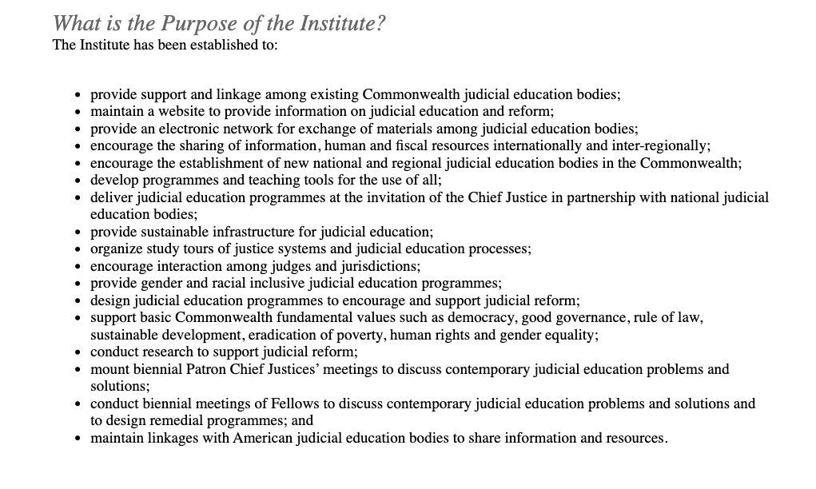For more information on the CJEI please see: <http://cjei.org/index.html>