North End Community Health Clinic
The NECHC continues to be part of the OBGYN residents’ rotation schedule and continues to be held once a month.
The first clinic of 2020 will be held on January 15th.
Phoenix House and Adsum House
The GHU reached out to Phoenix House and Adsum House about restarting the education session initiatives previously held at these two locations. Both are interested and details will be discussed in January 2020.
Ghana Memoranda of Understanding Signed!
After years of work, MOUs between the IWK and Korle Bu Teaching Hospital, and Dalhousie University and the University of Ghana were finally signed! These MOUs will solidify the relationships we have built with these institutions and ensure long lasting collaboration and partnership.

Newcomer Health Clinic
Our OBGYN residents and staff members continue to run the Newcomer Women’s Health Clinic on Mumford Road offering education and services to newcomer/refugee women. The next prenatal class will be held on January 23 and will tackle post-natal care and breast feeding. Volunteers needed!

For more information, please contact Hala Nader at hala.nader@iwk.nshealth.ca.
The following is a list of global health events and deadlines that may interest our OBGYN staff, residents and personnel, as collated by
The Dalhousie Global Health Office.

Submission deadline: Jan 22, 2020:
Global Health Annual Review – Call for Papers
Feb 28 & 29, 2020 in Halifax:
East Coast International Development Summit
Submission deadline: Mar 2, 2020
Global Health Awards 2020
Mar 13 & 14, 2020 in Halifax:
Dalhousie Crossroads Interdisciplinary Health Research Conference
For a comprehensive list of events, please explore the bi-weekly Global Health Office Bulletin

Global Health Unit
Newsletter December 2019
Department of
Obstetrics and
Gynaecology
Announcements
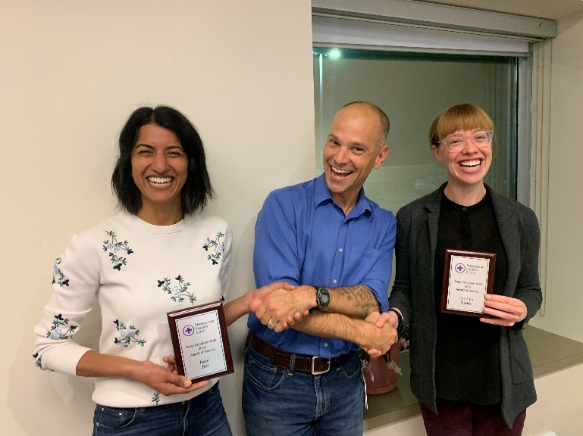
The Well Women Clinic is a great global health initiative tackling community needs in our own backyard. The initiative was initially started by senior residents in 2015; their focus was to educate newcomer women on contraception and cervical cancer screening. What was supposed to be a one-time event turned into a monthly clinic after family physicians at the Newcomer Clinic saw a need to provide more consistent, regular gynecological care to women. Thus, the resident physicians in the Dalhousie University Obstetrics and Gynaecology program partnered with family physicians at the Halifax Newcomer Health Clinic to run a dedicated, monthly Well Women Clinic. The goals of the clinic are to:
Global Health Unit Spotlight: The Well Women Clinic

- Educate refugee women about cervical cancer screening to promote awareness and uptake
Dr. Navi Bal and Dr. Jocelyn Stairs receiving the Ampi Kanakam-Kidd Award from Dr. Tim Holland.
- Provide contraceptive counselling and IUD placement
- Create a discrete, safe, female-centric environment
- Foster resident advocacy and cultural competency through long-term partnerships
Female patients who are seen through the Halifax Newcomer Health Clinic are offered appointments at the Well Women Clinic. Women are assigned a dedicated interpreter and participate in a teaching session prior to their clinic appointment. Residents are recruited on a volunteer basis to participate and provide care to these women under the supervision of a family physician. In October 2019, Dr. Tim Holland presented Drs. Navi Bal and Jocelyn Stairs with the Ampi Kanakam-Kidd Award of Service for their incredible work at the Well Women Clinic. They dedicated the award to “the two wonderful admin staff that support and organize the clinic”.
Fall at the Global Health Unit
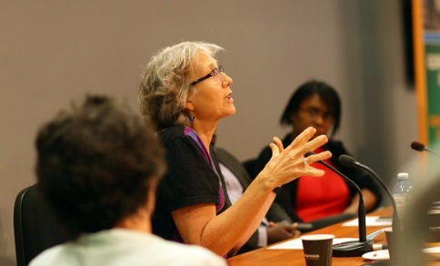
The Global Health Unit was involved in various events throughout the fall. On September 25th 2019, Dr. Heather Scott, the Director of the Global Health Unit, was a panelist in the panel discussion organized by the Dalhousie Global Health Office for their annual Global Health Day: “Global Health Interventions: Lessons From Nova Scotia and West Africa”; other panelists included Dr. Janice Graham, Dr. Buba Manjang and Dr. Gaynor Watson-Creed.

On October 3rd 2019, the ObsGyn Global Health Unit hosted a panel discussion to explore reproductive rights and advocacy. Panelists included our own Dr. Melissa Brooks, as well as two lawyers, Kelly McMillan and Jennifer Taylor, who discussed their work and the importance of advocacy and impact of reproductive rights advocacy in Canada.
Dr. Heather Scott during the Global Health Day panel discussion

On November 5th 2019, the Department of Surgery held an event to explore Visiting Teams in Global Health and answer the question: How have visiting teams been most useful and what are their main challenges. The event was held in collaboration with the Anesthesia and ObsGyn Global Health Units and consisted of three short presentations by Dr. David Horne, Dr. Ananya Abate and Dr. Mahalet Tadesse Ibssa.

